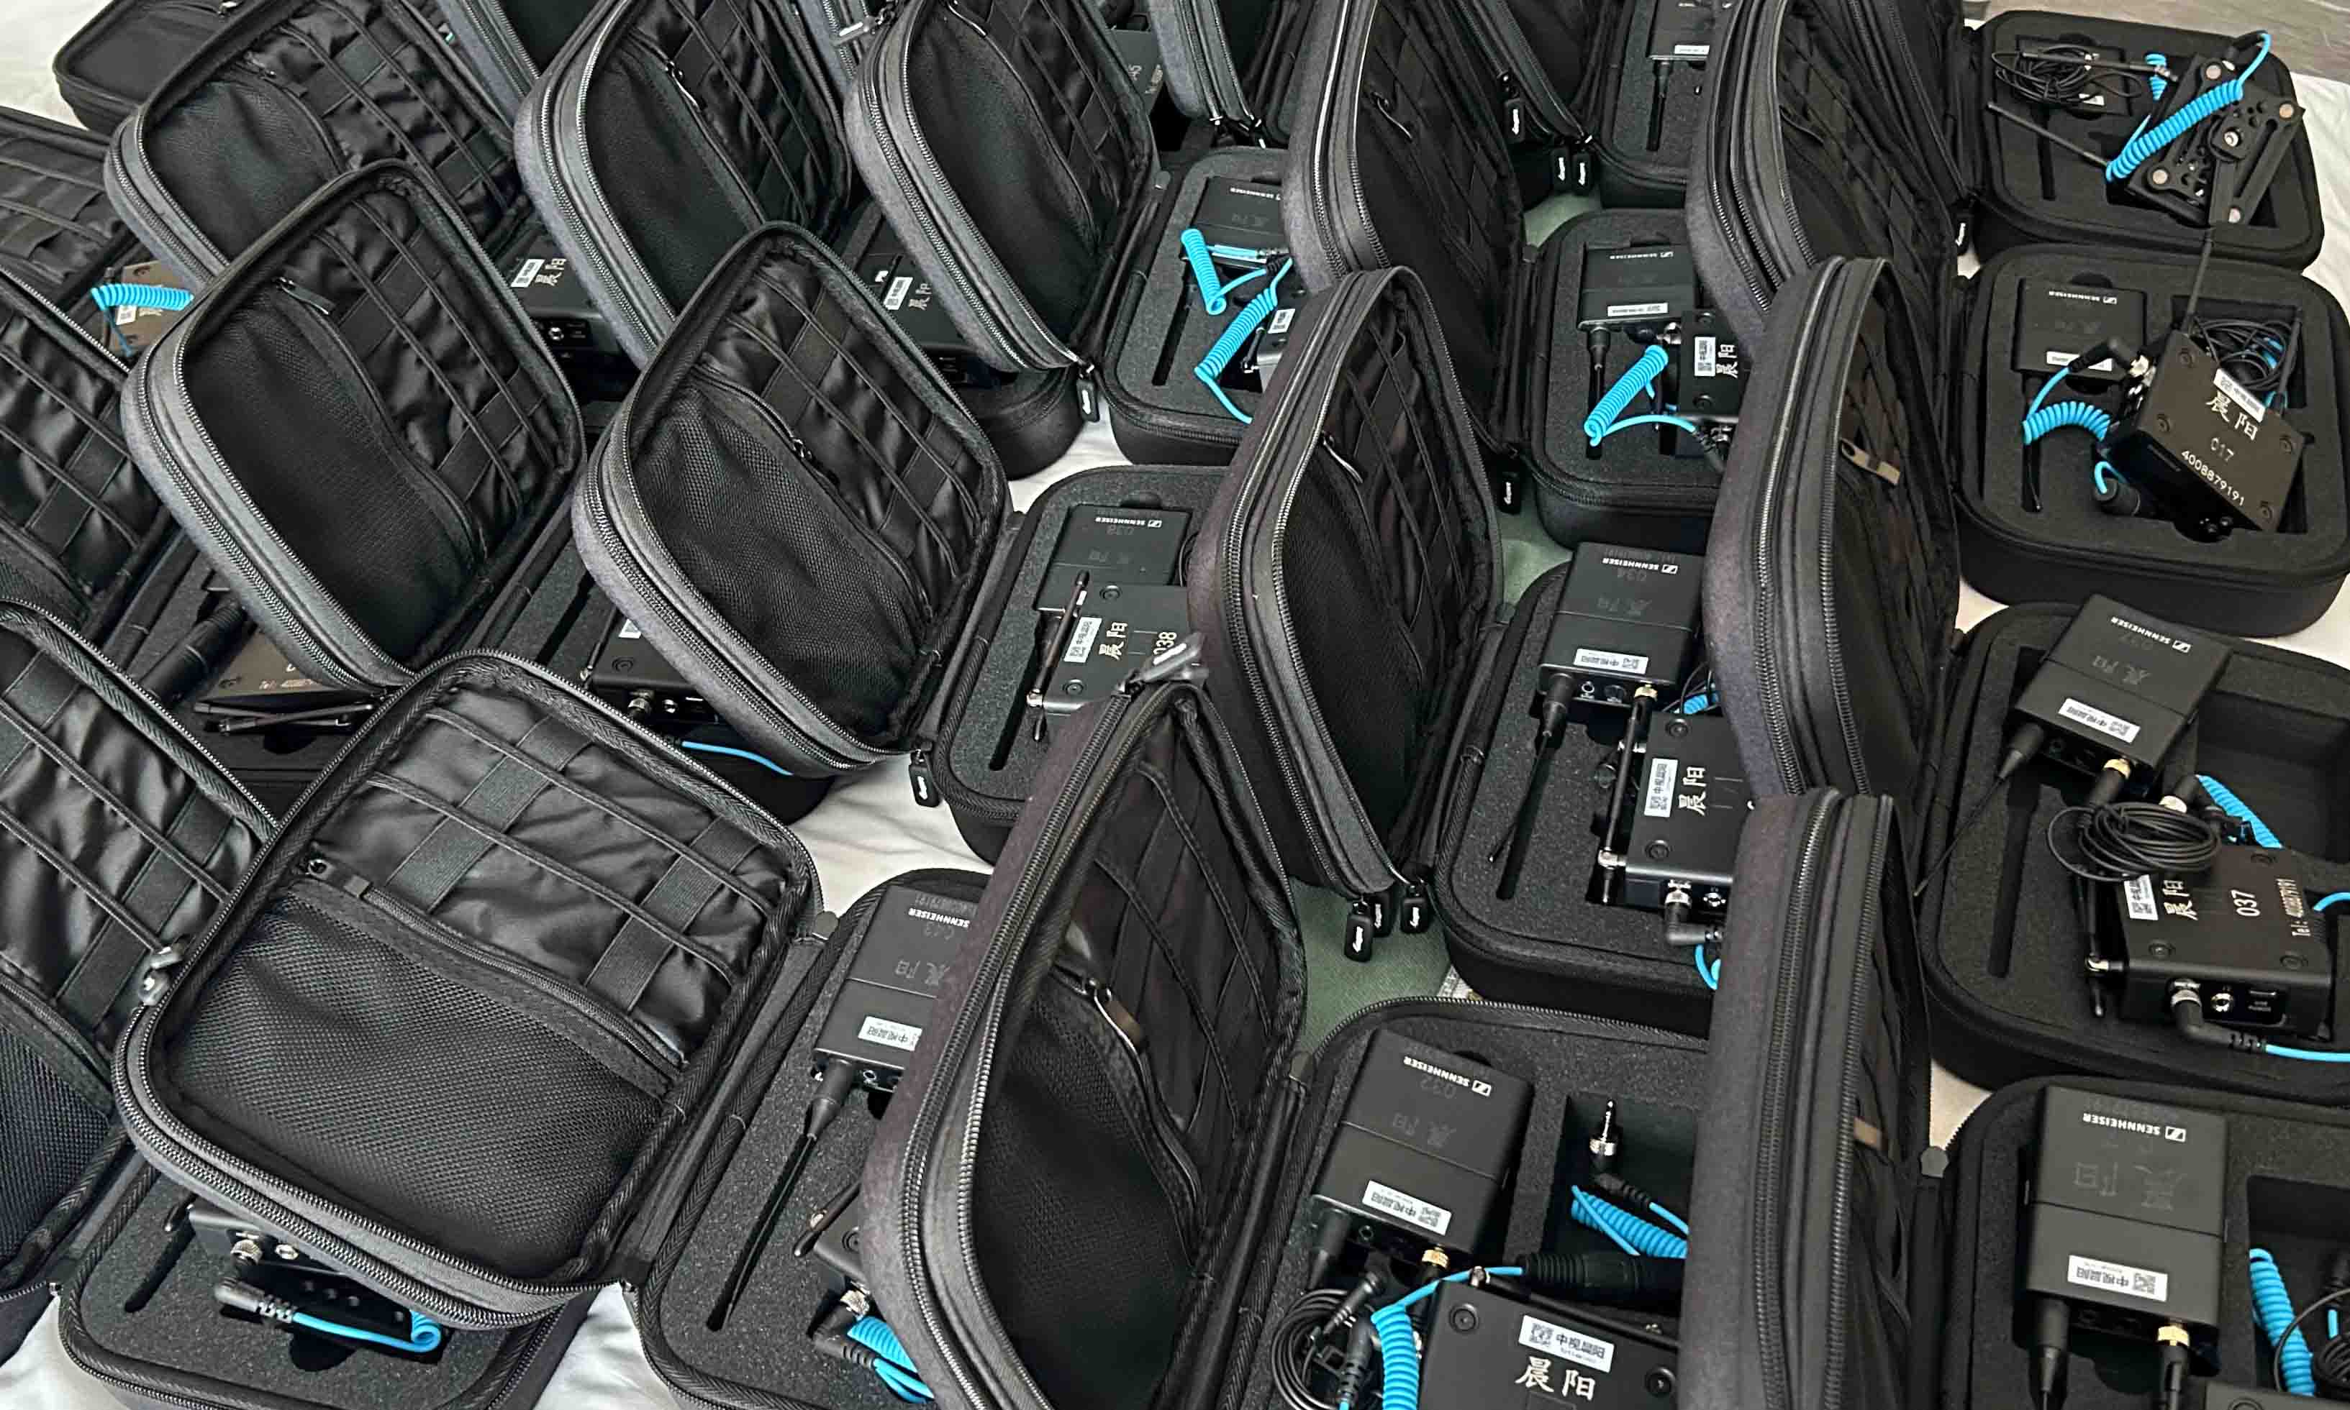

Sennheiser Wireless improves audio quality of outdoor reality show
Shanghai Media Group chooses EW-DP to meet the multiple challenges of outdoor programme recording with excellent sound quality and outstanding reliability

Shanghai, 29 May 2024 – “Go Fighting! Treasure Walk” is a popular outdoor reality show created by Shanghai Media Group (SMG). Now in its fourth season, “Go Fighting! Treasure Walk - Harmonious Countryside” has gained both recognition and popularity among audiences by showcasing the stunning landscapes and local customs of China's countryside. However, shooting the complex outdoor scenes created many challenges for the audio system design – until the programme’s team selected a 40-channel Sennheiser EW-DP system. This all-digital, UHF camera microphone system ensured clear and stable sound, setting a new benchmark for audio system design in outdoor reality shows.

In this season, the film crew visited a number of locations across all regions of the country, from quiet hamlets in the valleys to ancient villages surrounded by mountains. The beautiful scenery, bustling crowds and fun interactions between the guests made the programme exciting, but was also challenging for capturing clear on-site audio.

Xu Mengyu, Head of Audio, was responsible for the season’s sound recording, including vocals, ambient sound and sound reinforcement. After more than a month of field testing and comparison, Xu Mengyu chose 40 channels of EW-DP for its excellent sound quality and stability.

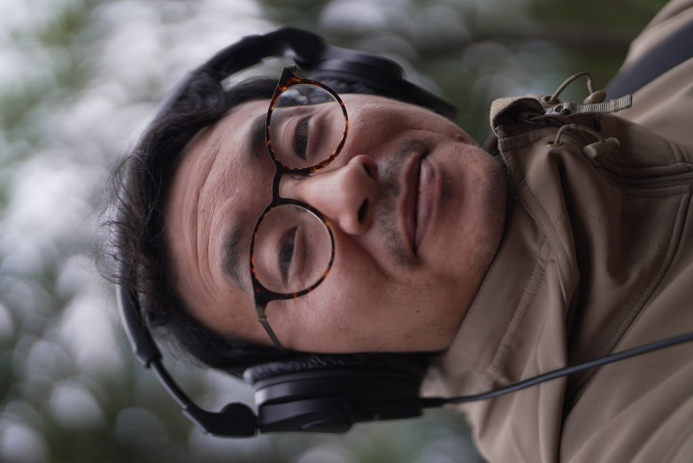 | After more than a month of field testing and comparison, Xu Mengyu chose 40 channels of EW-DP for its excellent sound quality and stability

Xu is a longtime user of the Sennheiser EW 112P G4, and he appreciates the audio quality, operability and reliability of the product. However, after hearing about Sennheiser’s new EW-DP and trying it out, Xu Mengyu was even more impressed with its outstanding performance. He shared: “We tested the EW-DP to its limit. It performed amazingly well, and with the same Sennheiser quality as always. The subsequent recording process went smoothly, with the EW-DP delivering clear and stable sound quality, reliability and a great user experience.”

As a member of the Evolution Wireless Digital family, the EW-DP inherits the technical advantages of the series. With equidistant channel spacing and automatic frequency coordination, the EW-DP receiver can quickly find the best free frequency and synchronise with the transmitter via Bluetooth, greatly simplifying the videographer’s operation process. Thanks to 56 MHz of tuning bandwidth and equidistant frequency spacing, up to 90 channels can automatically be preset by EW-DP. Xu remarked: “When I need to change the frequency on the spot, EW-DP is intuitive and easy to operate, saving me a lot of valuable time and energy.”

There are many sources of interference in an outdoor recording location. The variety of signal interference often causes frequency dropouts or sound loss, which was another major challenge the audio team faced, and also required absolute stability from the audio equipment. As a digital UHF wireless digital microphone system, EW-DP’s outstanding anti-interference stability impressed Xu Mengyu. “EW-DP’s stability is so strong!,” he said. “It is almost completely unaffected by any external signal interference. I no longer need to worry if there are telecoms towers nearby.”
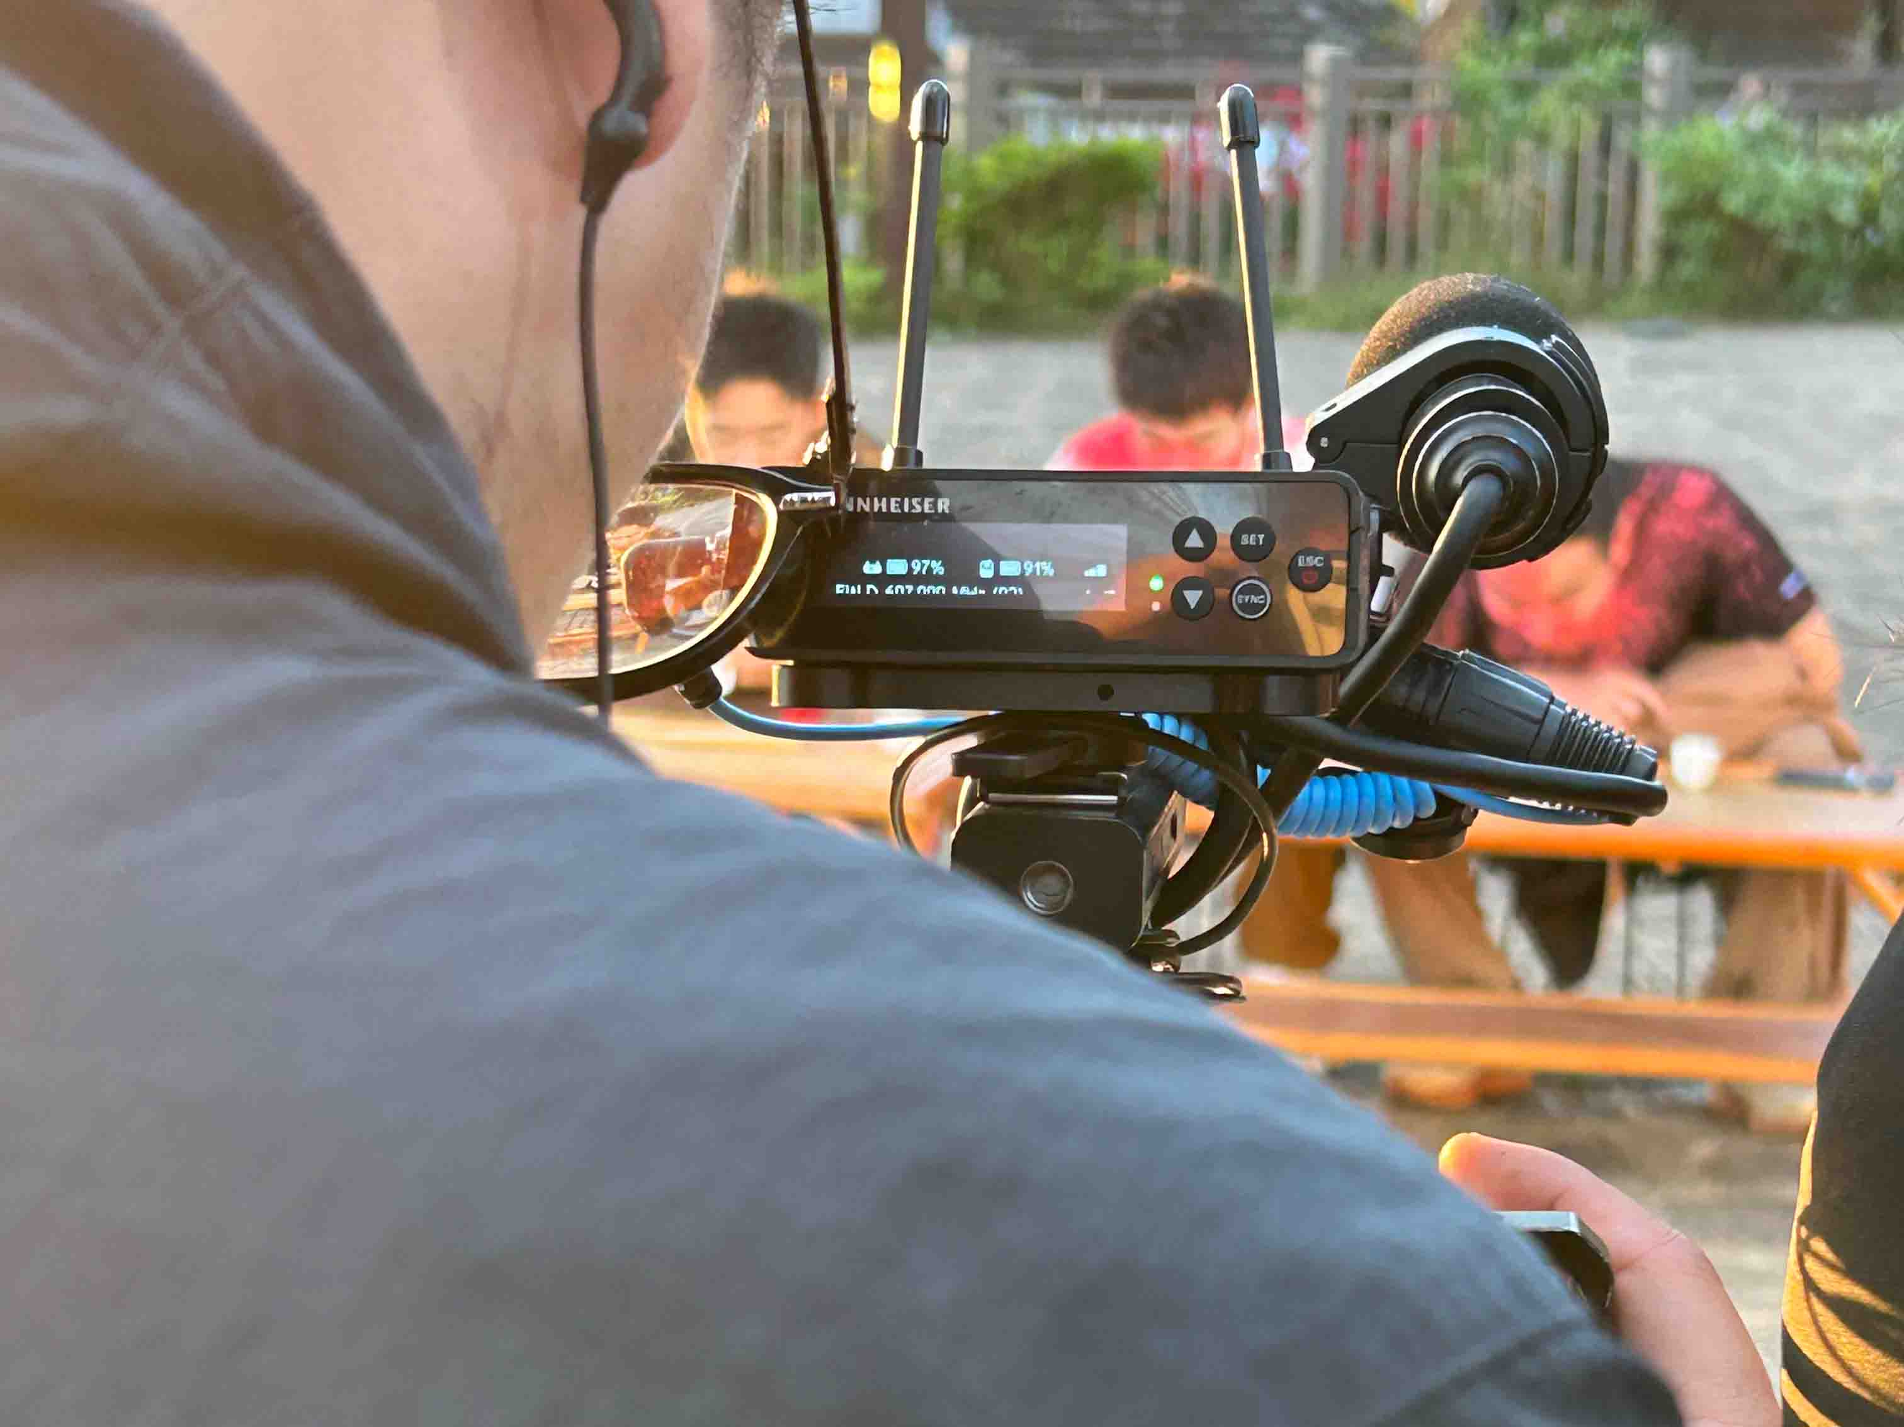
The whole recording process was very smooth. EW-DP delivers clear and stable sound quality, outstanding reliability, and great user experience

In addition, outdoor programme recording has very high requirements for the security of audio materials, so the programme team often record multiple backup tracks simultaneously. At the same time, the executive director needs to listen to the guests in real time. In response to these practical needs, Xu Mengyu’s team designed a radio system for the programme with one transmitter matching four receivers, i.e. one EW-DP SK transmitter paired with four EW-DP EK receivers.

The EW-DP EK receivers have an innovative magnetic stacking system. The first EK receiver is mounted onto the main camera through a magnetic mounting plate. The second and third receivers are connected to two Sound Devices 688 recorders for recording backup audio files. Xu Mengyu also specially modified the antenna of one of these receivers with a Sennheiser ADP UHF passive directional antenna, which further enhances the signal reception range to better ensure the stability of the signal in an extremely complex environment. The fourth receiver was used by the executive director for monitoring.

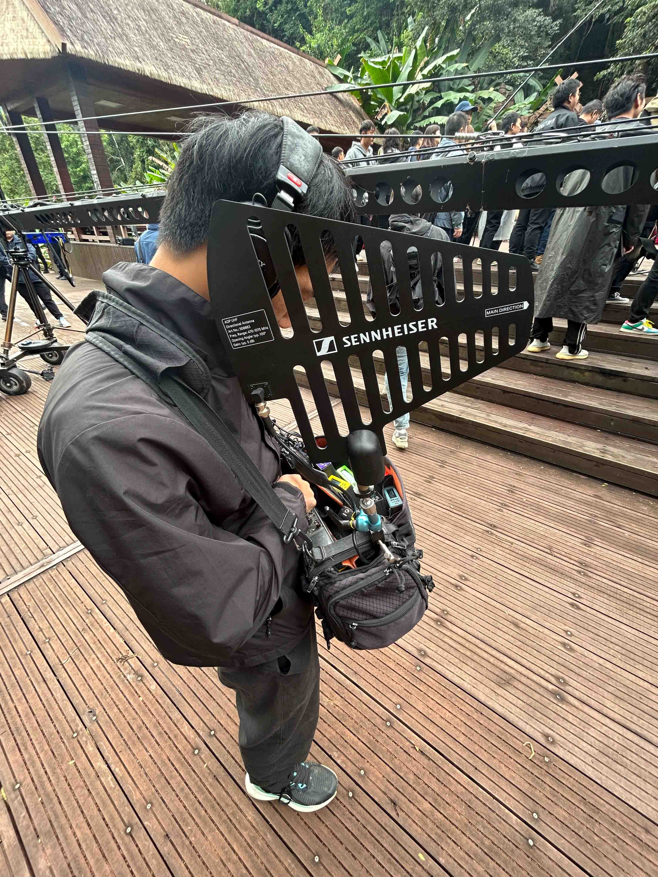 | Xu Mengyu modified the antenna of one of the receivers recording the backup track into a passive directional model. This further enhanced the signal reception range, increasing signal stability in an extremely complex environment

Reality shows are characterised by their sense of realism, so the cameraman is often unable to follow the guests at close range. This requires not only reliable and robust radio equipment, but also easy operation and excellent visualisation of information, so that the cameraman can easily monitor the equipment in real time.

“The EW-DP’s user-friendly interface is ideal for programme making. All controls and settings are made on the receiver, and the bodypack transmitter only has two internal buttons, which effectively prevents guests from accidentally touching them,” praised Xu Mengyu. “The EW-DP’s powerful OLED display brings great convenience to our work. It faces the cameraman, and we know the exact runtime of the batteries at any time without having to rely on experience to make an estimate, which allows us to deal with unforeseen situations. This is an unprecedented experience and very important for outdoor reality show recording! There is no doubt about the outstanding performance of the EW-DP. Its flexibility in use has also made our audio system design much easier.”

Xu and his team are already working hard to prepare for the start of their next programme. They are looking forward to relying on Sennheiser’s EW-DP to bring the audience another exciting audio-visual feast.

The images accompanying this media release can be downloaded here.

About the Sennheiser brand
We live and breathe audio. We are driven by the passion to create audio solutions that make a difference. Building the future of audio and bringing remarkable sound experiences to our customers – this is what the Sennheiser brand has represented for more than 75 years. While professional audio solutions such as microphones, meeting solutions, streaming technologies and monitoring systems are part of the business of Sennheiser electronic GmbH & Co. KG, the business with consumer devices such as headphones, soundbars and speech-enhanced hearables is operated by Sonova Holding AG under the license of Sennheiser.

www.sennheiser.com
www.sennheiser-hearing.com

Local Press Contact
Ivy Gu
ivy.gu@sennheiser.com

